Objectives

- Define SPA and its benefits
- Define React and identify its working
- Identify the differences between SPA and MPA
- Explain Pros & Cons of Single-Page Application
- Explain about React
- Define virtual DOM
- Explain Features of React

In this hands-on lab, you will learn how to:
- Set up a react environment
- Use create-react-app

Prerequisites

The following is required to complete this hands-on lab:
- Node.js
- NPM
- Visual Studio Code

Notes

Estimated time to complete this lab: 30 minutes.

Create a new React Application with the name “myfirstreact”, Run the application to print “welcome to the first session of React” as heading of that page.
- To create a new React app, Install Nodejs and Npm from the following link:
https://nodejs.org/en/download/
- Install Create-react-app by running the following command in the command prompt:

- To create a React Application with the name of “myfirstreact”, type the following command:

- Once the App is created, navigate into the folder of myfirstreact by typing the following command:
- Open the folder of myfirstreact in Visual Studio Code
- Open the App.js file in Src Folder of myfirstreact
- Remove the current content of “App.js”
- Replace it with the following:

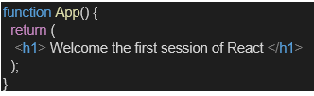

- Run the following command to execute the React application:

- Open a new browser window and type “localhost:3000” in the address bar

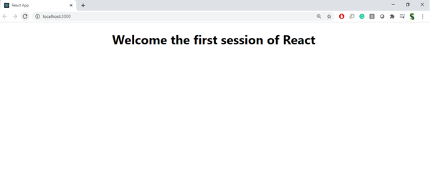
Output:
